OFTP2 Onboarding Service - Project Documentation
Inhaltsverzeichnis
OFTP2 Onboarding Service - Project Documentation 1
Project Vision 2
Key Stakeholders 2
Solution 2
Overview 2
Breakdown 2
Business 3
Value Proposition 3
Target Customers 4
Pricing Model 5
Costs 5
Project 5
Timeline 5
Deliverables 5
Risk Assessment 6
Business Risks 6
Technical Risks 6
Strategic Risks 6

Project Vision
Manual partner onboarding for complex communication protocols such as OFTP2 is time-consuming and prone to errors. Seeburger provides CMA to support partner onboarding; however, preparing onboarding packages with CMA still requires significant effort. To increase customer adoption of CMA, an out-of-the-box solution is needed that minimizes configuration effort and enables a short time-to-value for productive use.
This project aims to provide a low-effort onboarding path for OFTP2 partners for customers operating BIS 6.7 (iPaaS and on-premises) using CMA. The primary objective is to minimize customer-side development and avoid any additional installation on the customer’s BIS runtime.

Key Stakeholders
- Product Owner: Frank Stolle
- Technical Lead: TBD
- Business Analyst: TBD
- Operations Lead: TBD

Solution

Overview
The solution introduces an API facade between CMA and BIS 6.7. The facade abstracts the underlying BIS 6.7 Transport API into a simplified, stable contract that CMA can consume.
The facade is implemented as an Integrator Workspace (IWS) flow. This keeps the integration logic outside the customer’s BIS runtime while providing an API surface for CMA-driven onboarding operations. The implementation also demonstrates a reusable IWS-based integration pattern for CMA ↔ BIS 6.7 scenarios.
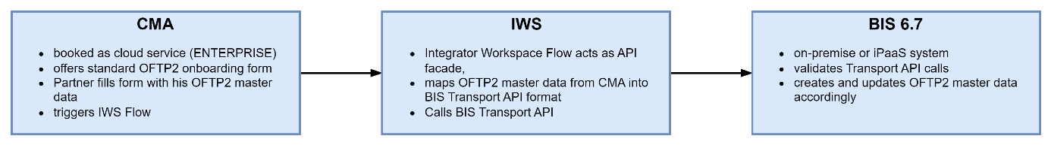

Breakdown
- Uses the BIS 6.7 Transport API to bundle the creation, update, and assignment of all components required for an OFTP2 partner setup into a single API call. The Transport API also provides built-in rollback, reverting all changes if an error occurs.
- Encapsulates the business logic around the BIS Transport API in an Integrator Workspace (IWS) flow, which acts as a facade API callable by any client (in our case, CMA).
- Uses CMA’s API integration feature to generate a CMA form for OFTP2 and connect it to the IWS flow.
- The IWS flow receives the relevant OFTP2 parameters from the CMA form and builds the payload for the BIS Transport API.
- For new partners: the flow retrieves an OFTP2 transport template from the customer’s BIS (including all required references and assignments), maps the partner-specific OFTP2 parameters into it, and submits it to BIS via the Transport API.
- For existing partner updates: if a transport for the partner already exists, the flow retrieves it from BIS, applies the updated OFTP2 parameters from CMA, and sends the updated transport back to BIS via the Transport API.
- The facade API can also be reused to integrate with other platforms or tools.
- Implements the facade using an Integrator Workspace (IWS) flow to keep it lightweight and avoid any additional installation on the customer’s BIS 6 system.
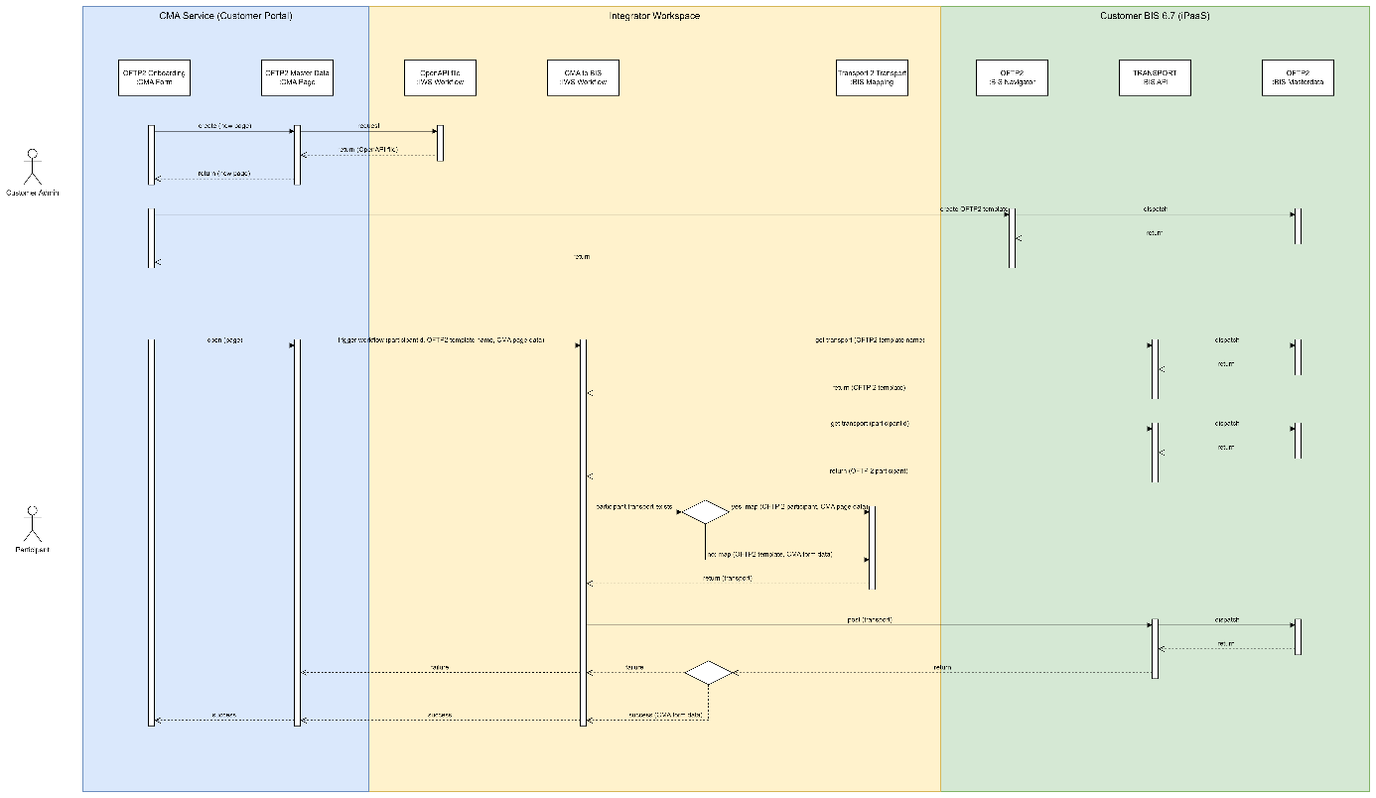

Business

Value Proposition
For Customers:
- Cost Reduction: A budget-friendly subscription model replaces high upfront development costs.
- Out-of-the-Box: Replaces manual onboarding preparation (via CMA) with a ready-to-use, standardized service.
- Accelerated Time-to-Value: Drastically reduces time-to-value from months to merely days.
- Error Reduction: A standardized cloud service minimizes the errors often associated with on-premise installations and highly customized solutions.
- Convenience: Requires zero software installation and handles all updates automatically.
For Seeburger:
- Transformation: Drives our internal learning and transition from traditional product offerings to service-based models.
- Competitive Advantage: Demonstrates market superiority by offering seamless, superior onboarding services.
- Platform Bridge: Serves as the crucial first point of contact for BIS 6 customers entering the IWS ecosystem.
- Customer Insights: Provides deeper, actionable visibility into exactly how customers utilize our products and services.
- Future Opportunities: Establishes a scalable foundation for future services, such as AS2, Communication Gateway, and more.

Target Customers
- customers with more than 100 partners
- customers who are not using communication per B2B Routing Service

Primary
- BIS 6.7 iPaaS: Cloud-hosted BIS customers (iPaaS) with CMA cloud services, lowest support effort

Secondary
- BIS 6.7 on-premises: On premises BIS customers with CMA cloud services, medium support effort
- BIS 6.7 any deployment without CMA, new business

Tertiary
- BIS 6.7 any deployment: with CMA subscription, migrating to cloud services

Industry Verticals:
Industries where OFTP2 is comon:
- Automotive industry (OEMs, Tier 1-2 suppliers)
- Manufacturing companies
- Aerospace
- Logistics providers
- Retail supply chain partners

Pricing Model

Current Pricing Model:
- BASE: 550 EUR / month including provisioning and up to 20 onboardings / month
- UNLIMITED: 2.500 EUR / month including provisioning and unlimited onboardings
- API ADD-ON: 100 EUR / month usage of CMA API to manage partner onboardings per API

New Pricing Model
- BASE: 550 EUR / month including provisioning + up to 20 onboardings / month
- ENTERPRISE: 3.000 EUR / month including provisioning + unlimited onboardings + CMA API + OpenAPI integration + Content Packages ("OFTP2 Onboarding for BIS 6", ...)
Expected Revenue p.a.: 3.000 EUR x 12 month x 5 customer = 180.000 EUR

Costs
- Development Project Effort:
  - 90 days development
    - 15 days refinement
    - 15 days design
    - 35 days implementation
    - 10 days testing
    - 15 days deployment
  - 30 days cloud devops
  - 15 days management
  - Total effort: 135 days
- Infrastructure: Hosted as part of existing platform — Marginal
- Maintenance: Ongoing support — Low
- Operations: Monitoring, updates — Low

Project

Timeline
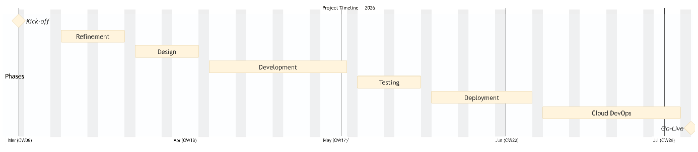

Deliverables
- OpenAPI Specification: A complete API definition to automatically generate the OFTP2 configuration form within the CMA.
- IWS Workflow & Mapping: Fully configured integration flows and data mappings required to seamlessly create and update OFTP2 transports.
- Cloud Service Deployment: Complete provisioning and delivery of the CMA Enterprise Service within the SEEBURGER Cloud.
- Comprehensive Documentation: Tailored enablement materials, technical guides, and standard operating procedures (SOPs) for the Sales, Consulting, and Operations teams.

Risk Assessment

Business Risks
Risk | Likelihood | Impact | Mitigation
Low adoption | High | Medium | Make CMA Enterprise more atractive e.g. with more protocols like AS2
Maintenance | Medium | Medium | MVP approach with controlled rollout, no on-premise deployments
Resource constraints | Medium | High | Leveraging more ressources to implement standard content for CMA
Development costs | Medium | Low | Reviewing project in early stage with customers

Technical Risks
Risk | Likelihood | Impact | Mitigation
BIS mapping limitations | Low | Medium | Proven technology, existing patterns  Known limitation: missing option to create mappings with multiple sources in web mapper
Integration complexity | Medium | High | Changes in any of the components CMA, IWS, BIS6.7 may lead to corruption of the service
IWS limitations | Medium | Medium | Addressed missing features: Flow shoud be able to response with failure, flow should offer API
Incomprehensible error messages from BIS Transport AP | High | Medium | Trying to fix it with AI, MCP

